

National University
of
Computers & Emerging
Sciences

DLD LAB- Final Project
(4-Bit Calculator Hardware)
Ahmed Ubaid
Zahra Arshad

Introduction:
This project focuses on designing a 4-bit calculator and simulating it as Hardware. The calculator takes the input in binary and can perform the operations like addition, subtraction, multiplication, arithmetic logical operations (AND, OR, NOT, XOR) and display the answer in BCD 7 segment display. The purpose of this project was to learn how basic digital components work together to perform real tasks. This report explains all the parts used in the project, the ICs involved, and how each part such as the adder, subtractor, ALU, multiplier, and converter was built and tested.
ICs Used in the Project:
- AND
- OR
- NOT
- XOR
- 2x4 DECODER (74LS139)
- 4 BIT ADDER
- 7 SEGMENT DISPLAY
Each component for the calculator i.e. 4-Bit Adder Subtractor, 4-Bit ALU, 4-Bit Multiplier and Convertors for the calculator was made separately as a device and then the whole calculator was linked together by enablers and decoder to select the operation to be performed. After the operation is performed the binary output goes through the converter where the binary output is converted into BCD and then displayed using 7 Segment Displays
4-Bit Calculator:

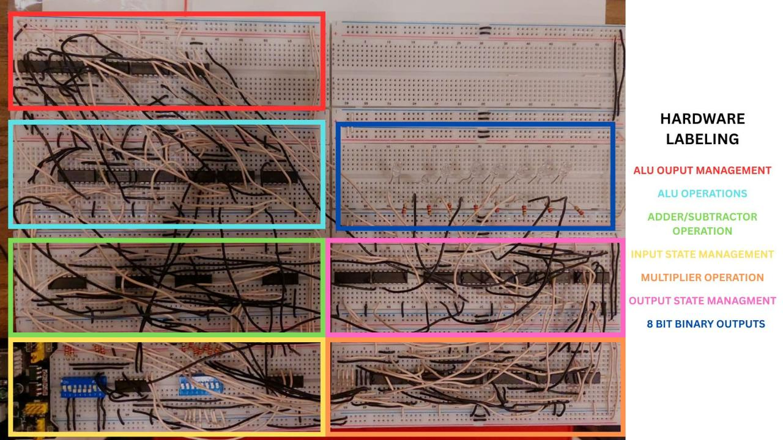

The calculator uses different binary inputs to enable the operations to be performed
Mode Selection | Binary Value | ALU Mode | Binary Value
Addition | 00 | AND | 00
Subtraction | 01 | OR | 01
ALU | 10 | NOT | 10
Multiplication | 11 | XOR | 11

Adder & Subtractor:
4-Bit Adder & Subtractor:
The 4-Bit adder subtractor uses a 4 Bit Adder to calculate the sum when the enabler is 0. In case of 1 the adder IC is used to calculate the difference.
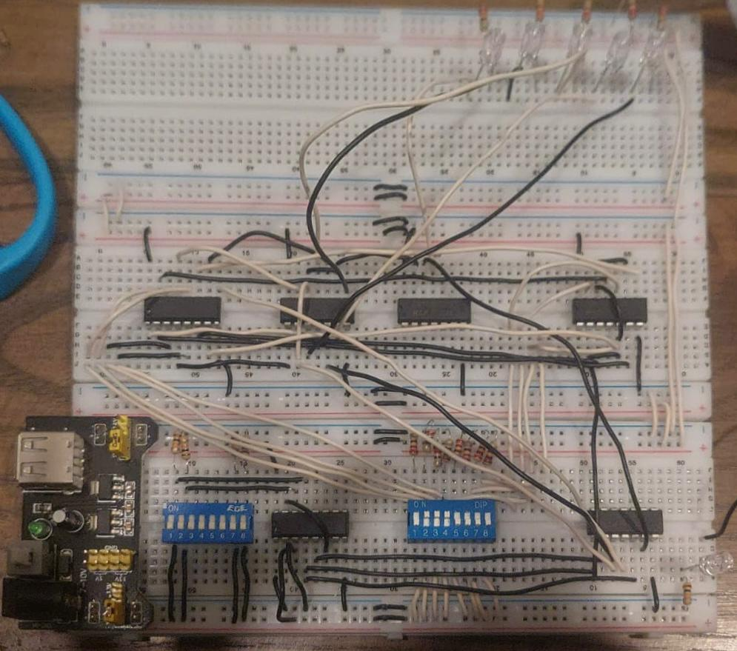

ALU:
4-Bit ALU:
The 4-Bit ALU works on the enabler to find AND, OR, NOT, and XOR of the input. It performs the operations on a 4-Bit input.

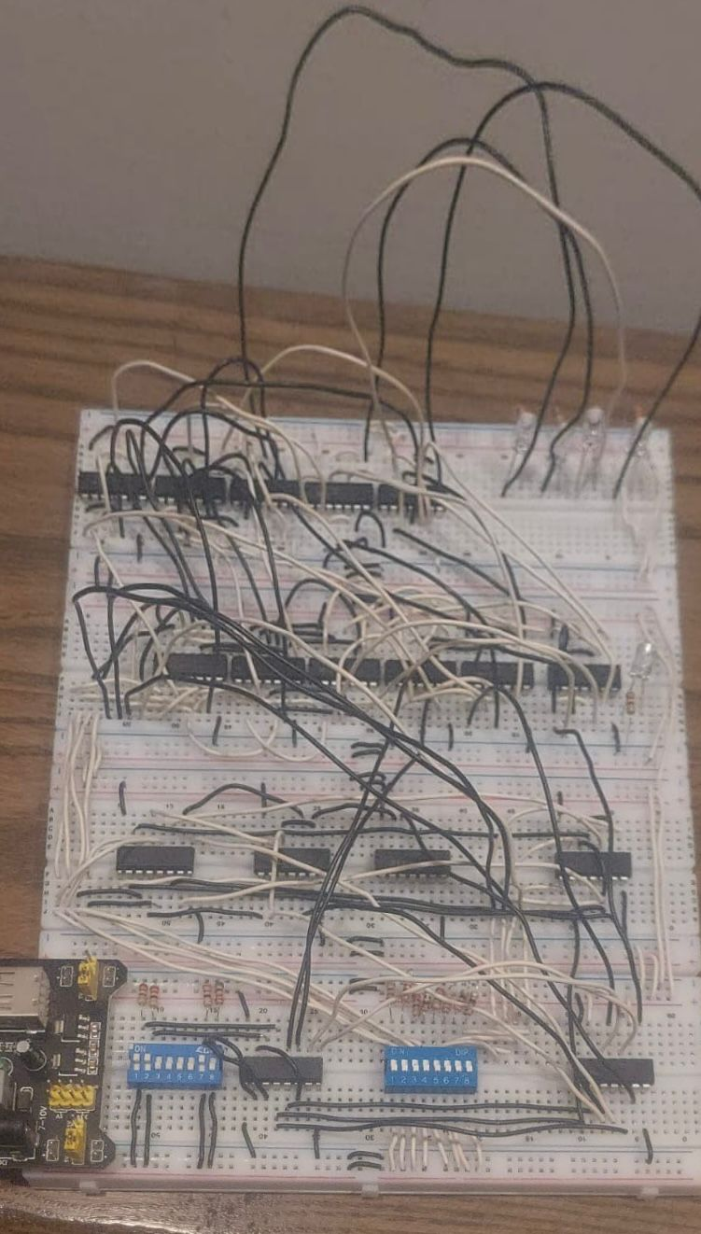

Multiplier:
4-Bit Multiplier:
The 4-bit multiplier is designed using AND gates and adders. It multiplies two 4-bit binary numbers by generating partial products and adding them using 4-bit binary adders. This circuit gives an 8-bit output as the final product.

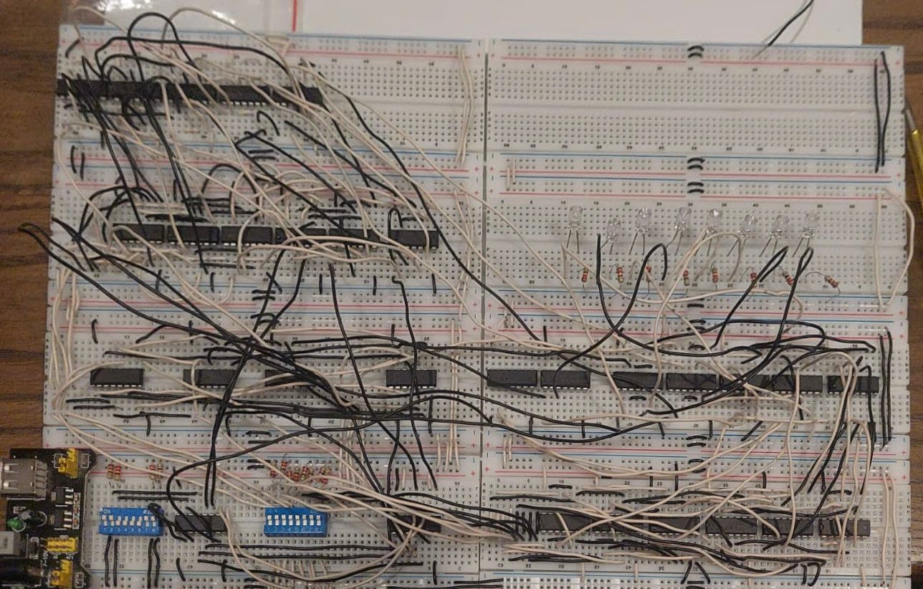

Converter:
4-Bit Calculator Convertor:
This converts an 8-bit binary number into three BCD digits (hundreds, tens, units) using the Double Dabble algorithm. The external circuit passes the binary bits through identical converter blocks. Each internal block uses logic gates to check BCD values allowing accurate BCD conversion for display on 7-segment outputs.

NOTE:
The Converter part is not yet completed at hardware level as it requires a complex circuits inculding requring 3 more breaadboards and 20 more ICs

Conclusion:
In this project we designed a 4-Bit Calculator using logic gates and ICs. We bulit and tested different parts like the adder, subtractor, multiplier, and converter in Proteus and on Hardware level. It improved our understanding of how digital circuits work and how to solve problems in logic design.

References:
- https://electronics.stackexchange.com/questions/713730/how-to-convert-16-bit-to-decimal-on-multisim. (for converter)

